Online Bus Ticket Booking System
1. Aim
To design and develop an Online Bus Ticket Booking System using HTML and CSS that allows users to register, log in, search for buses, view bus details, book and cancel tickets, and view booking history. It also provides an admin interface to manage bus information, bus categories, registered users, comments, news, and reports.
2. Software Required
- Operating System: Windows
- Front-end Technologies: HTML5 and CSS3
- Code Editor: Visual Studio Code / Notepad++
- Web Browser: Google Chrome / Microsoft Edge
3. Algorithm
- Start the program.
- Create the home page using HTML and CSS.
- Create the user registration page to collect user details.
- Design the login page with change password and forgot password options.
- Create a bus search form to enter the source, destination, journey date, and time.
- Display available buses with bus type, departure time, arrival time, fare, and available seats.
- Design the seat selection page for choosing seats.
- Create a passenger details form and ticket booking page.
- Design pages for viewing booking history and cancelling tickets.
- Create a comments section for users to post feedback about buses.
- Develop an admin dashboard to manage bus categories, bus details, schedules, and seat availability.
- Add options to manage registered users, news, and comments.
- Design a report generation page for displaying booking and bus information.
- Link all pages using HTML hyperlinks and apply CSS styling.
- Open the home page in a web browser and verify the layout, forms, and navigation.
- Stop the program.
HTML:

<!DOCTYPE html>
<html lang="en">
<head>
<meta charset="UTF-8">
<meta name="viewport" content="width=device-width, initial-scale=1.0">
<title>EasyBus - Online Bus Ticket Booking</title>
<link rel="stylesheet" href="style.css">
</head>
<body>
<header>
<h1>EasyBus</h1>
<p>Book your journey with comfort</p>
<nav>
<a href="#home">Home</a>
<a href="#search">Search Buses</a>
<a href="#account">Register / Login</a>
<a href="#bookings">My Bookings</a>
<a href="#comments">Comments</a>
<a href="#admin">Admin</a>
</nav>
</header>

<main>
<section id="home" class="hero">
<h2>Online Bus Ticket Booking</h2>
<p>Search buses, select seats and manage your tickets easily.</p>
<a class="button" href="#search">Book Your Ticket</a>
</section>

<section id="search">
<h2>Search Buses</h2>
<form id="searchForm">
<label>From</label>
<input id="from" placeholder="e.g. Chennai" required>

<label>To</label>
<input id="to" placeholder="e.g. Bengaluru" required>

<label>Journey Date</label>
<input type="date" id="travelDate" required>

<button type="submit">Search Buses</button>
</form>
<p id="searchMessage"></p>
<div id="busList" class="grid"></div>
</section>

<section id="account">
<h2>User Account</h2>
<div class="grid">
<form id="registerForm" class="card">
<h3>Registration</h3>
<label>Full Name</label>
<input id="regName" required>
<label>Email</label>
<input type="email" id="regEmail" required>
<label>Password</label>
<input type="password" id="regPassword" minlength="6" required>
<button>Register</button>
</form>

<form id="loginForm" class="card">
<h3>Login</h3>
<label>Email</label>
<input type="email" id="loginEmail" required>
<label>Password</label>
<input type="password" id="loginPassword" required>
<button>Login</button>
<button type="button" id="forgotButton">Forgot Password?</button>
</form>
</div>
<p id="accountMessage"></p>
<p id="currentUser">Please register or log in.</p>
<button type="button" id="logoutButton">Logout</button>
</section>

<section id="bookings">
<h2>My Booking History</h2>
<div id="bookingList"></div>
</section>

<section id="comments">
<h2>Bus Comments and Reviews</h2>
<form id="commentForm">
<label>Select Bus</label>
<select id="commentBus"></select>
<label>Your Comment</label>
<textarea id="commentText" rows="3" required></textarea>
<button>Post Comment</button>
</form>
<div id="commentList"></div>
</section>

<section id="admin">
<h2>Administrator Panel</h2>
<p>Demo login: admin@easybus.com / Admin123!</p>

<form id="adminLoginForm">
<label>Admin Email</label>
<input type="email" id="adminEmail" required>
<label>Admin Password</label>
<input type="password" id="adminPassword" required>
<button>Admin Login</button>
</form>

<div id="adminPanel" hidden>
<h3>Add or Update Bus</h3>
<form id="busForm">
<label>Bus ID (enter an existing ID to update)</label>
<input id="busId" placeholder="Leave empty to add a bus">

<label>Bus Name</label>
<input id="busName" required>

<label>Bus Category</label>
<select id="busCategory">
<option>Volvo</option>
<option>Sleeper Coach</option>
<option>AC Coach</option>
<option>Non-AC Coach</option>
</select>

<label>From</label>
<input id="busFrom" required>

<label>To</label>
<input id="busTo" required>

<label>Departure Time</label>
<input id="busTime" type="time" required>

<label>Ticket Price (₹)</label>
<input id="busPrice" type="number" min="1" required>

<label>Total Seats</label>
<input id="busSeats" type="number" min="1" max="100" required>

<label>Bus Photo URL (optional)</label>
<input id="busPhoto" type="url" placeholder="https://example.com/bus.jpg">

<label>Description</label>
<textarea id="busDescription" rows="2"></textarea>

<button type="submit">Save Bus</button>
<button type="button" id="clearBusForm">Clear Form</button>
</form>

<h3>Manage Bus Information</h3>
<div id="adminBusList"></div>

<h3>Manage Bookings</h3>
<div id="adminBookingList"></div>

<h3>Reports</h3>
<button type="button" id="reportButton">Generate Report</button>
<div id="reportOutput"></div>

<button type="button" id="adminLogout">Admin Logout</button>
</div>
<p id="adminMessage"></p>
</section>
</main>

<footer>
<p>EasyBus | Internet Programming Lab Experiment</p>
<p>Demo website for educational purposes.</p>
</footer>

<script src="script.js"></script>
</body>
</html>

CSS:

* {
box-sizing: border-box;
}

html {
scroll-behavior: smooth;
}

body {
margin: 0;
font-family: Arial, sans-serif;
background: #f2f6fa;
color: #243447;
line-height: 1.6;
}

header {
background: #12334d;
color: white;
text-align: center;
padding: 22px 12px;
}

header h1 {
margin: 0;
font-size: 34px;
}

nav {
display: flex;
justify-content: center;
flex-wrap: wrap;
gap: 12px;
margin-top: 15px;
}

nav a {
color: white;
text-decoration: none;
padding: 8px 12px;
border-radius: 5px;
}

nav a:hover {
background: #275a78;
}

main {
width: 92%;
max-width: 1100px;
margin: 25px auto;
}

section {
background: white;
margin-bottom: 24px;
padding: 22px;
border-radius: 10px;
box-shadow: 0 3px 12px #0000000d;
scroll-margin-top: 15px;
}

.hero {
text-align: center;
padding: 45px 20px;
background: #dcecf8;
}

.hero h2 {
font-size: 30px;
}

.grid {
display: grid;
grid-template-columns: repeat(2, minmax(0, 1fr));
gap: 18px;
}

.card, .bus-card, .booking-card {
border: 1px solid #d6e0e9;
background: #f9fbfd;
border-radius: 8px;
padding: 16px;
margin: 12px 0;
overflow-wrap: anywhere;
}

form {
display: flex;
flex-direction: column;
gap: 8px;
}

label {
font-weight: bold;
}

input, select, textarea {
width: 100%;
padding: 11px;
border: 1px solid #c5d0dc;
border-radius: 5px;
font: inherit;
}

button, .button {
display: inline-block;
background: #087f8c;
color: white;
border: none;
border-radius: 5px;
padding: 10px 15px;
cursor: pointer;
text-decoration: none;
margin-top: 8px;
}

button:hover, .button:hover {
background: #05616c;
}

button:disabled {
background: #999;
cursor: not-allowed;
}

.bus-card img {
display: block;
max-width: 100%;
max-height: 180px;
object-fit: cover;
border-radius: 6px;
}

footer {
text-align: center;
padding: 18px;
background: #12334d;
color: white;
}

[hidden] {
display: none !important;
}

@media (max-width: 650px) {
main {
width: 96%;
}

section {
padding: 15px;
}

.grid {
grid-template-columns: 1fr;
}

nav {
flex-direction: column;
gap: 3px;
}

.hero h2 {
font-size: 24px;
}
}

OUTPUT:
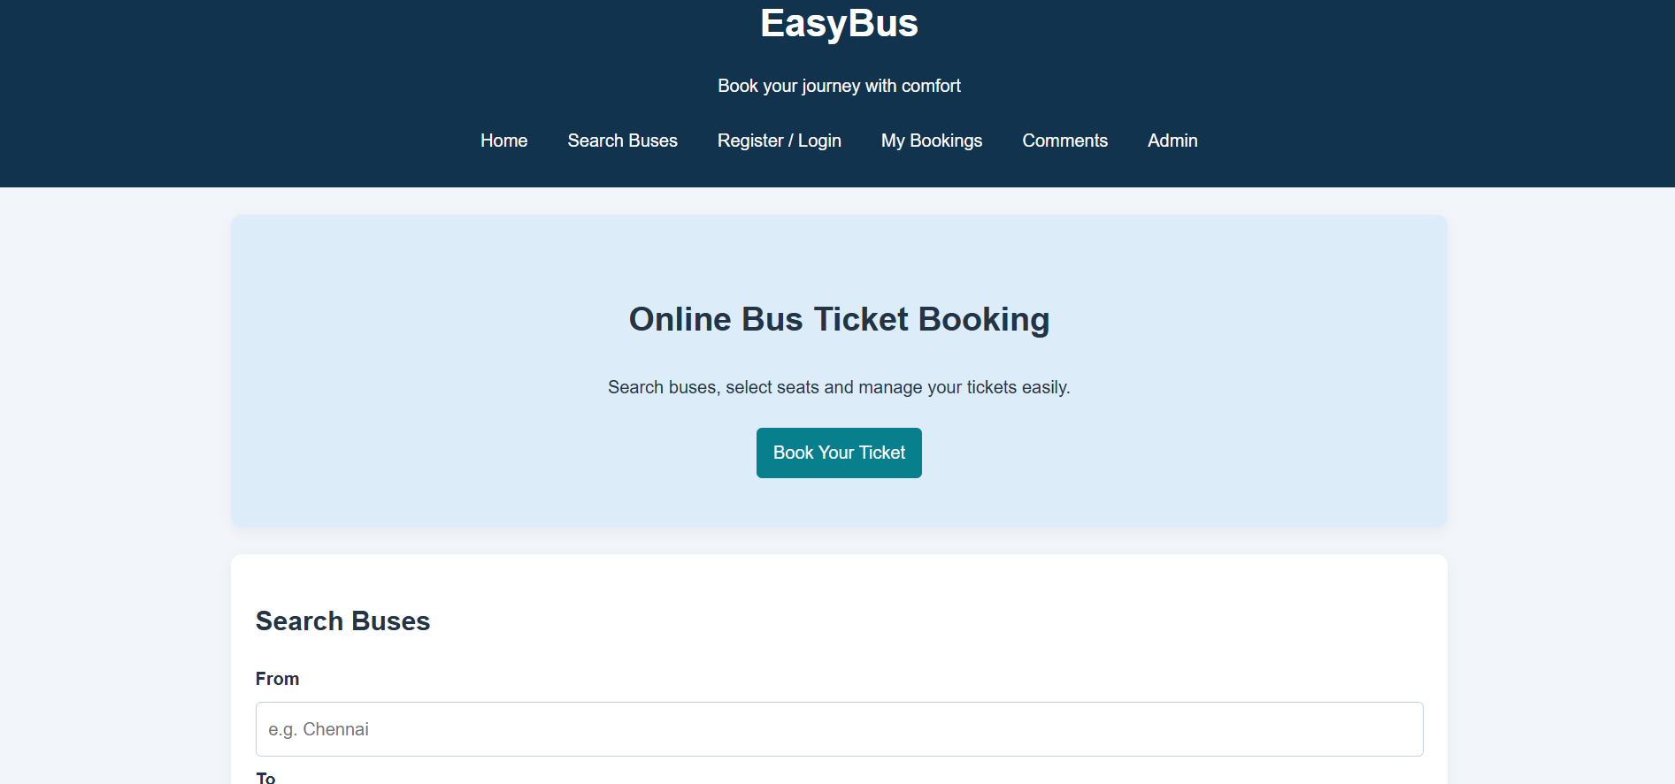
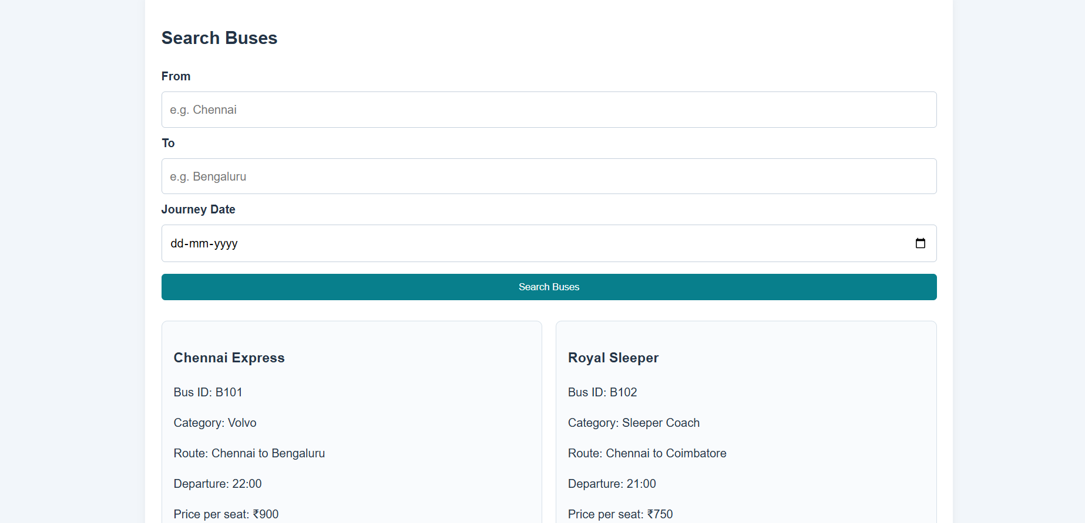
4. Result
Thus, the Online Bus Ticket Booking System was designed using HTML and CSS. The website includes user registration and login, bus search, bus details, seat selection, ticket booking, booking cancellation, comments, and booking history pages. It also provides an admin dashboard for managing bus information, categories, users, news, and reports.

